**Name of Dataset Collection** - Kenya Integrated Household Budget Survey 2015-2016

**Specific datasets used** - Consumption Aggregate and Credit1 Data

**Process**

1. Converted DTA files to usable files for google collab
2. Cleaned up the data - filled in missing values
3. Using the list of columns, questions were created to answer economic opportunity insights
4. Graphs were created for each question to help visualize the results.

**Consumption Aggregate Dataset:**

Average Household sizes:

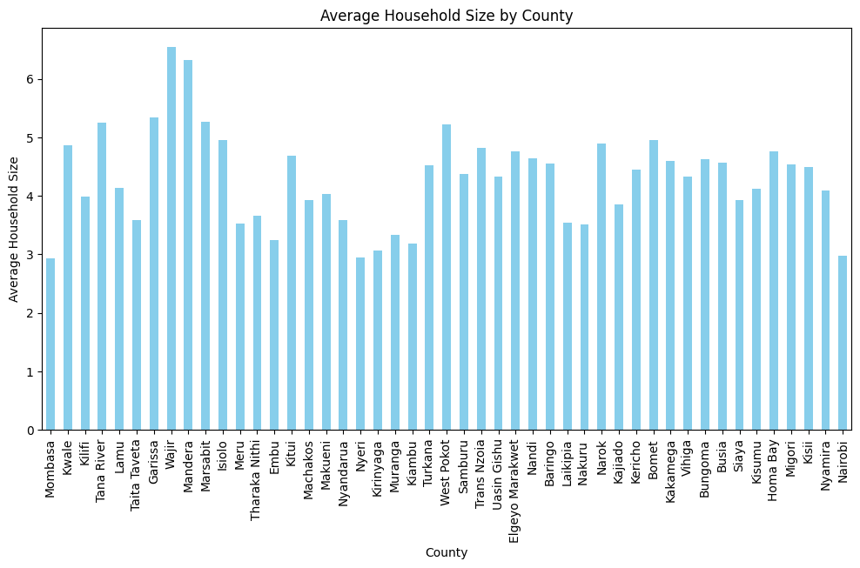

Total spendings for the different counties:

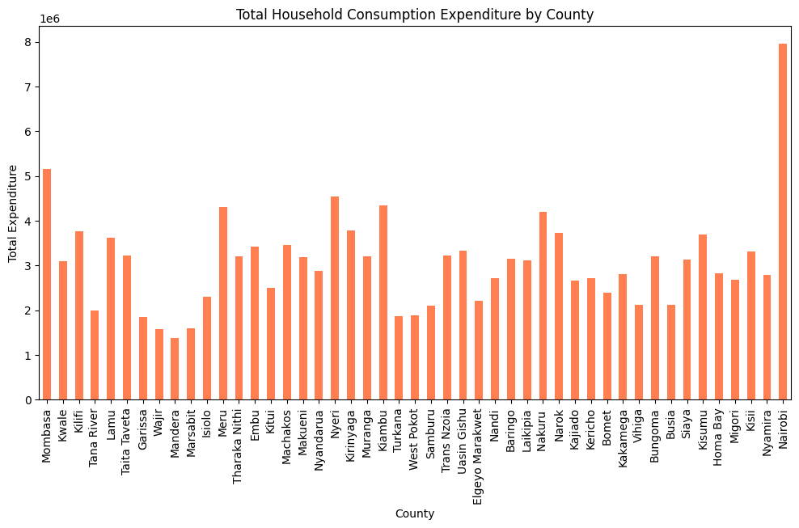

Food vs nonfood consumption

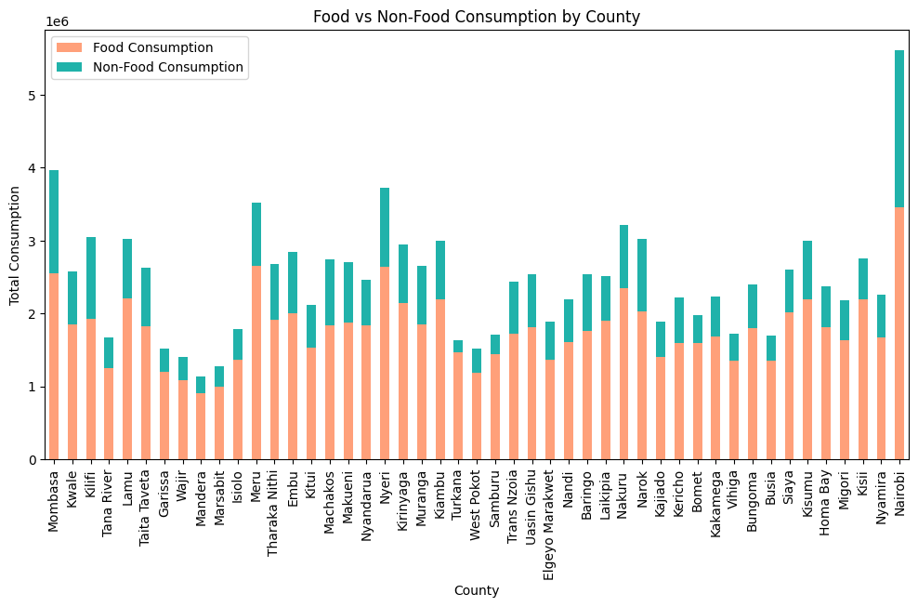

Household Sizes vs non food consumption

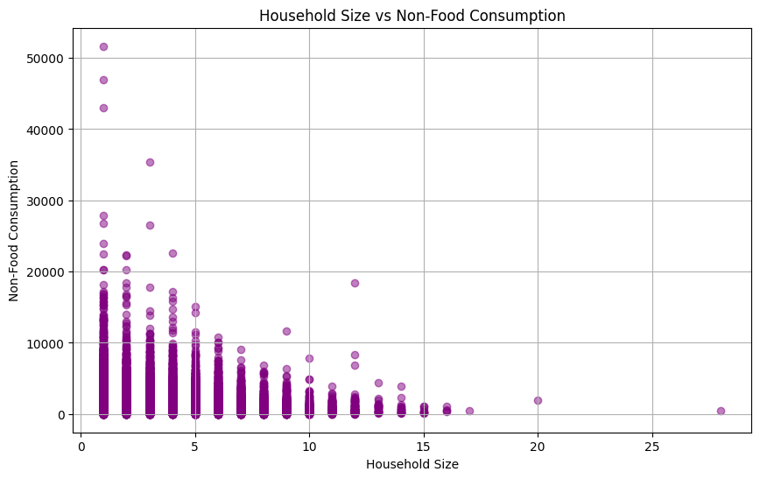

**— CREDIT1 DATASET—**

**What are the most common reasons people borrow money?**

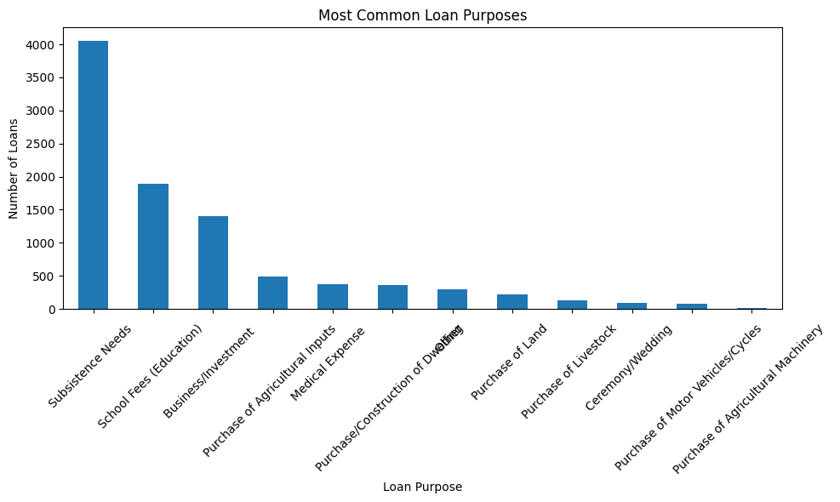

**What is the average loan size across different credit providers?**  
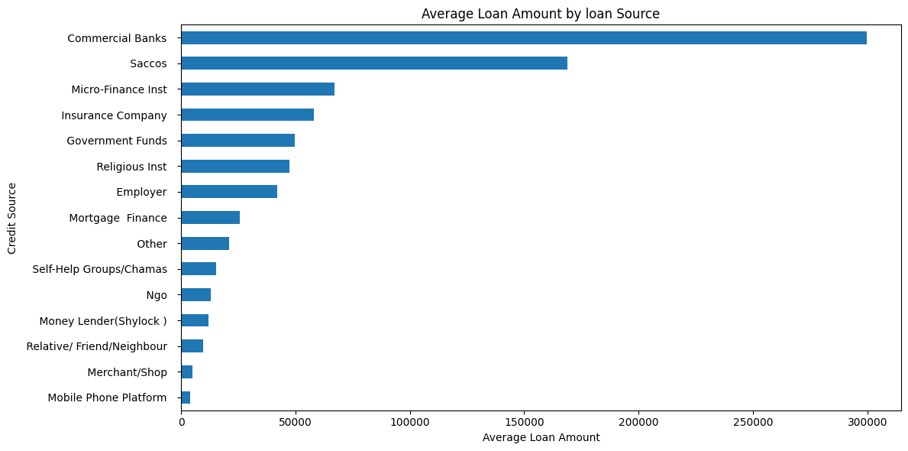

How does loan repayment success vary by loan purpose or source?

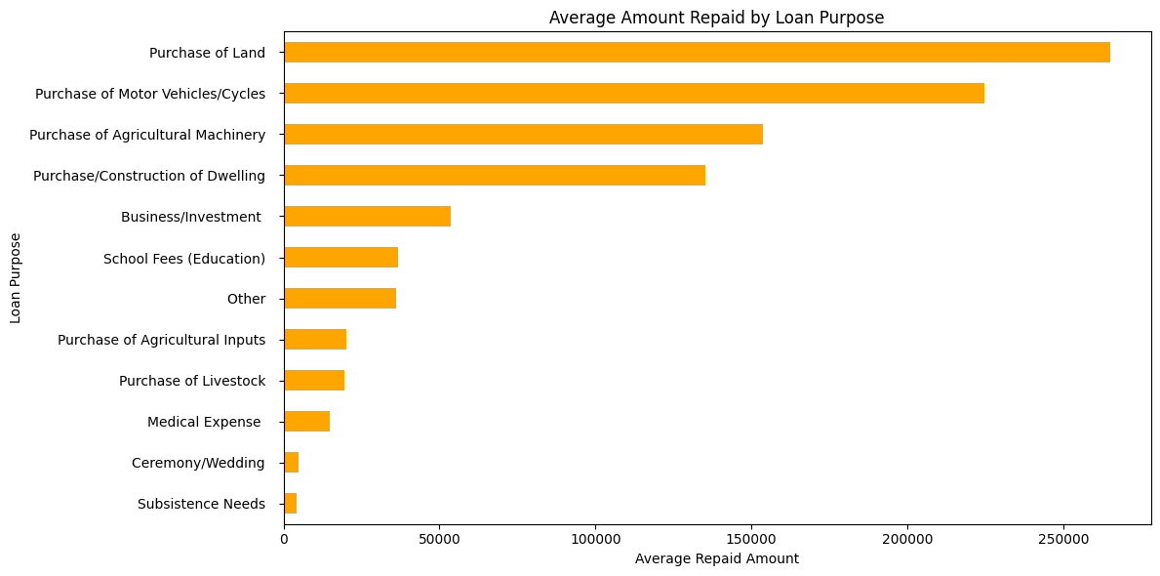

What sectors (education, business, agriculture) are getting the most financial support?

